Name: Nokwazi Hope Malunga
Group:2
Student number: 10100228
Module name: Programming 2B
Module Code: 6212

SYSTEM MANUAL ON USING THE ASP.NET CORE APPLICATION

TABLE OF CONTENTS
Login …………………………………………………………………………………………………………….
Buttons………………………………………………………………………………………………………….
Labels……………………………………………………………………………………………………………
Forgot password…………………………………………………………………………………………..
Registration…………………………………………………………………………………………………..
Modules………………………………………………………………………………………………………..
Graph…………………………………………………………………………………………………………….

Users can login on the login page. The Email and the password are it two field on the login page that allows those who have already registered to just use the login page to gain easy and quick excess to the page. The password will be validated after the inputs are compared to our user database. The user will then move on to the main menu after the verification is been finished. A remember me option has been put into place for the user or student to click the small box next to it for the system to remember the user and their person details every time the choose to login into the system.

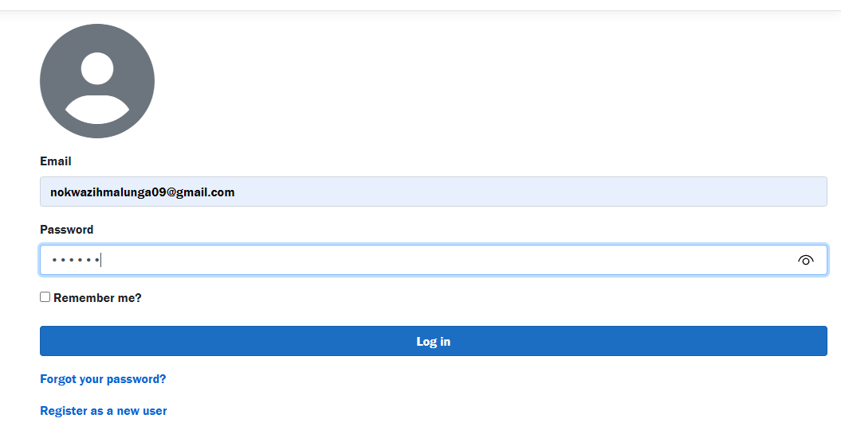

A login button has been provided there to be used “Clicked” when user has entered their personal details (Email, Password). A few options have been provided for the users if they have forgotten their password, they will have to use the “forgot your password?” option provided below use that option to processed further on to creating a new password or an email will be sent to you to remind you of your old password and you will have to confirm the email before get your old password back if interest in using it. This process will then continue with the login process and this information will be then captured and stored in a database followed by the register as new user for the new applicates to the system will be guided by this manual on how to go about filling int the information in the system provided to help processed with the application.

Register page
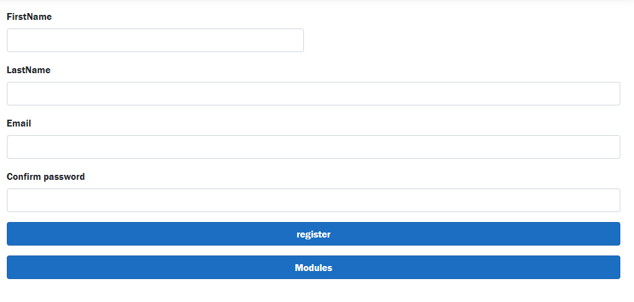

When the register as new use has be clicked the student or user can then processed in the registering in the application. The application below will require the user or student to answer or input their personal information on the following spaces provided
FirstName, Last Name, Email, Password and Confirm password in order to be registered as part of the new users of the system in order for them to gain easy excess to the application.
Below the information required above, followed by a register and a modules button in order to continue with the following. After the following buttons above have been pressed the information will be captured by the database system, then the user or the student is now registered to login anytime they need to use the system or application. The modules button will then process to the next part of the application that goes into more detail on what the applicate needs.
The module
Numerous factors determine how much time you should devote to your education, including:

Is the content offered in your native tongue?

If not, what level of fluency do you have in it?

How much of the subject are you already familiar with?

How rigid is the instructor?

How well-known is your degree program, course, or training session? Is it known for being very simple or really difficult?
This is why we want to keep track of how much time do student spend on self-study per week
The module part of the application is for the student to fill in information on the modules that a they are doing currently. This part of the application requires the student to fill in their module code, module name, number of credits of the days they will be studying that module on that particular day, and the start day and time will be required on the application. The purpose of the is part of the application is to captured data on the student on how much time do they spend on a daily basis on a particular module of they choice this data is then captured and stored into a database that will keep all the records of all this information. Not only does have to capture data but it also allows the lectures to see which modules do students need help in or which modules are being studied more than the other modules.
Graphs
Graphs area popular tool for visually illuminating data relationships. A graph serves the objective of presenting data that are either too many or complex to be fully expression in the text while taking up less room. In this application the purpose of a graph is to collect all the data from the login, registration page to the modules, it will only show the data collection for the amount of time students spend on a particular module and it will display It on the graph. Graphs and charts condense a lot of information into simple formats that communicate key ideas clearly and effectively.
There are also different types of graphs that display data in different types of ways A bar chart, in which each column represents the average value received from each age group, might be a preferable approach to display individual values. 4 When covering an exceedingly wide range and it is not practicable to do so with a continuous scale, represent the discontinuity in the scale and the data field using paired diagonal lines. At the end of the every week the graph will show the number or the amount of student who took the time to dos self-study that includes the start date ,time and end date.

Why collect data on student?
Concerns about the learning outcomes not keeping up with the growth of education are widespread. Since many nations lack regular statistics on who is and is not learning, the size of the learning gap is generally unknown. Data on the state of learning is provided through learning assessments, which can be used to track system effectiveness and student learning outcomes. In order to provide feedback and extra data for decision-making, regular monitoring can indicate changes over time in response to initiatives to enhance student outcomes. Data can be used to demonstrate whether increased public investment in education has led to measurable gains in student achievement, which can be used to hold the system responsible for the use of resources. Although the school bears the primary direct accountability for the outcomes, decision-makers at all administrative levels are accountable for creating the supportive policy and practice environment.

For self-study
For in order to obtain independence and the capacity to improve without depending on a teacher, self-learning is a crucial skill for kids to develop as they progress through school and into adulthood. To better understand where they thrive and where they need to grow, encourage students to evaluate their own work. If students regularly practice editing and evaluating their work, they'll rapidly feel at ease in the self-evaluation setting. Self-learning is actually quite beneficial to students who are time or location constrained because it can be done from the convenience of any place and at any time. Due to the number of so many online learning tools available, self-study techniques have developed. Self-learning allows you to learn what you want, when you want, and how you want. The learning process may be controlled by you, making it more effective than learning through traditional instruction

